Pneumatic Actuator Test Stand

Controller Settings Overview
  - Evan Comiskey – MIT FID Lab – 2024/08 – comiskey@mit.edu

Description:
This guide walks you through the functions of all variables relevant to the operation and adjustment of the test stand’s PID control software, in the order in which they appear in the main settings file. Any implied or uncontextualized purposes of variables discussed in this overview can likely be explained by reviewing the Test Stand & Controller Overview PowerPoint document

Table of Contents
Description: 1
1. Where Relevant Settings Live 2
2. Pin Definitions 2
3. Pneumatic Valve Settings 2
4. Filename Setting 3
5. Tuning Settings 3
6. Pressure Sensor Settings 3
7. Frequency Settings 4
8. PID Controller Settings 5
9. Trajectory Settings 5

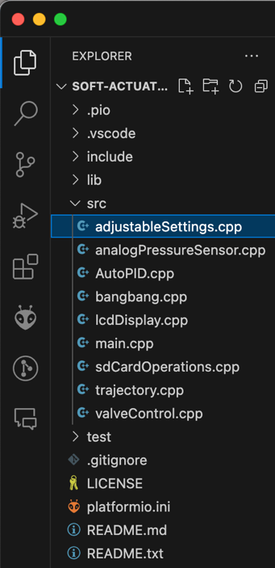
Where Relevant Settings Live
- You only need to interact with adjustableSettings.cpp to use the controller as originally designed in August 2024.
  - It is located within the src sub folder of the downloadable codebase shown at right.
  - For information on how to set up the codebase, see the Install, Tune, & Run the Controller Word document.

Pin Definitions
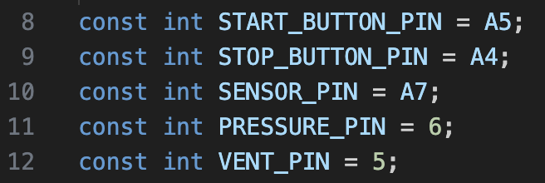
- The first five variables are static pin definitions for all the valves, sensors, and buttons involved in the controller logic. They should never be changed once initially set, unless the arrangement of your physical electronics has changes too.
  - Change the default definitions listed to those appropriate to your set-up if they differ.
  - PRESSURE_PIN and VENT_PIN must be PWM-capable pins on your microcontroller; if they aren’t the controller won’t be able to open/close the solenoid valves.

Pneumatic Valve Settings
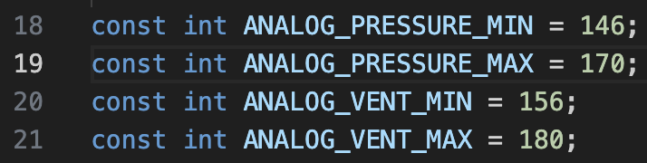
- These four variables dictate the minimum and maximum analog signals that can be sent to the solenoid valves.
  - The defaults listed in the code are specific to the set-up originally created for the MIT Fabrication-Integrated Design Lab in August 2024. Anytime you create a new version of this set-up with a different solenoid valve, even with the same exact model as listed in the original BOM, you must tune the controller program for that specific 2/2 solenoid valve.
  - Due to mechanical wear in the valves, you may need to retune your solenoid valves if you notice consistent, unexpected poor controller behavior.
- Tune the solenoid valve by following the tuning procedure described in the Install, Tune, & Run the Controller file.

Filename Setting
- The fileName setting allows the use of custom naming schemes for the test files generated by the controller. There is no restriciton on what can be included in the name, so long as it totals less than 50 characters.
- Test files are generated in the form fileName_#.csv, where # represents the lowest unused integer whereever the file is being saved.
  - At the start of a test, If cycle_test_1, and cycle_test_2 already exist, the controller will automatically create a new cycle_test_3 file to store the new test’s data

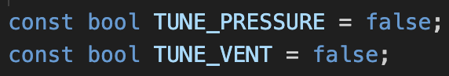
Tuning Settings
- TUNE_PRESSURE and TUNE_VENT should always be set to false, unless the system’s pressure and vent valves are being tuned as outlined in section 5 of the Install, Tune, & Run the Controller guide.

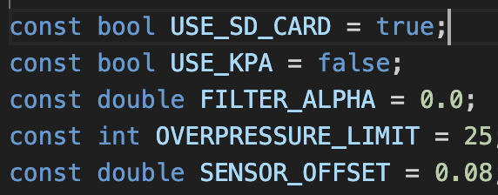
Pressure Sensor Settings
- USE_SD_CARD dictates where the data the controller generates during a test is sent.
  - If set to true, the controller writes all test data to a new csv file on the SD card.
  - If false, writes all test data to the serial port, where it can be intercepted and plotted in real-time by the LiveSerialPlotting.m script.
    - This will save all data to excel files of the form fileName_MATLAB_#.csv
    - Allows for quicker gain-tuning workflows
- The second of the five pressure-related settings is the USE_KPA Boolean.
  - If set to true, will interpret all pressure related values and variables in Kilopascals.
  - All pressure data coming from the pressure sensor will automatically be interpreted in units of Kpa and will be written to the microSD card that way as well.
  - If USE_KPA is set to false, the system behavior will remain the same, but use units of PSI.
- FILTER_ALPHA is passed to the pressure sensor collection logic and implemented as the coefficient in a simple low pass filter used to smooth the pressure data which is eventually fed to both the PID controller and recorded to the SD Card. \
  - During preliminary testing, it was found that even a filter alpha as low as 0.01 would make the controller noticeably more unstable for negligible smoothing benefit.
  - It is typically best to leave the controller off by setting the alpha equal to 0.
- OVERPRESSURE_LIMIT serves as a safety measure to prevent accidental overinflation of actuators.
  - Set the variables just under the safe operating limit of your actuator.
    - If your actuator bursts at 30 PSI, you will likely want to set this value somewhere around 25 PSI.
  - This setting directly interferes with burst testing trajectories and can lead to premature test endings, so be sure to alter along with your trajectory as appropriate.
  - It is not recommended to manually set a pressure max by adjusting the regulator down, as a lower inlet pressure differential will lead to a worsened ability for the controller to follow its programmed trajectory.
- SENSOR_OFFSET exists to allow calibration of the pressure sensor used in the system. Once set for a specific pressure sensor
  - It will not need to be adjusted again.
  - The offset will be different for every sensor
  - Recommend finding the offset for a specific pressure sensor using simple Arduino code that prints pressure values to Serial while the sensor sits at normal atmospheric conditions.

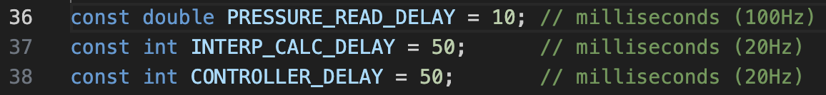
Frequency Settings
- These three settings determine the rate at which the microcontroller performs the following tasks:
  - Reads and writes the pressure data.
  - Writes other controller and cycle-related variables to the microSD card.
  - Performs trajectory interpolation (refer to the trajectory section for more information).
  - Updates the output of the PID controller.
- These values are frequency settings, but they must be set in units of milliseconds.
- It is recommended to keep these variables at their default values based on initial performance testing.
- If you do change these values, it is recommended to:
  - Keep INTERP_CALC_DELAY and CONTROLLER_DELAY at the same value. Performance seems to improve when both actions occur in sync.

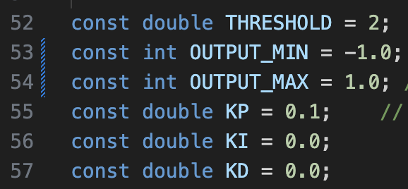
PID Controller Settings
- These 6 variables relate to the overall behavior of the proportional-integral-derivative (PID) controller and its outputs.
- THRESHOLD represents the range outside of which a test will fail if the controller fails to follow a non-zero setpoint.
  - If you set your trajectory function as a 15 PSI step function and set a 2 PSI threshold, then the test stopping safety logic will activate if the controller fails to stay within a range of 13-17 PSI for more than 2 seconds.
  - The added time delay prevents disturbances from abruptly ending tests early. It is recommended to set this threshold to 50% of your operating pressure for long form cycle or burst testing, to be able to characterize actuator behavior after material failure.
- OUTPUT_MIN and OUTPUT_MAX are helper variables that are used to map the outputs of the PID controller to the PWM signals defined in section 3 of this guide.
  - Do not change these variables from their defaults if you are not doing major restructuring to the code’s logic.
- KP, KI, and KD represent the gains for the proportional, integral, and derivative controller actions respectively.
  - Preliminary testing suggests starting with a KP value on the order of 10^{-1,} and a KI value on the order of 10⁻³
  - Do not involve derivative control (i.e., keep KD at 0) given its tendency to introduce high frequency instability into PneuNet systems.

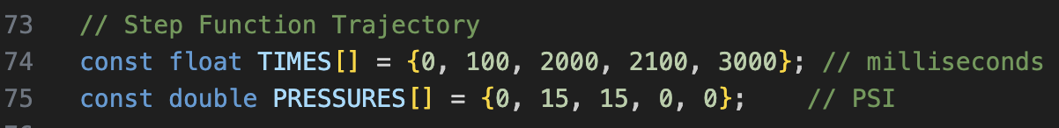
Trajectory Settings
- The last two variables listed in the file concern defining the trajectory settings of your controller.
  - For more definition on how to develop a trajectory function for the actuator to follow, see the Write Custom Trajectory Functions word document.
- TIMES is an array of time setpoints expressed in milliseconds, and PRESSURES contains the associated pressure setpoints for each time instance.
  - Ensure that these arrays are of the same length, else the program will fail to run properly.
- For convenience, example Step, Sawtooth, Reverse Sawtooth, Triangle, Sine, Ramp, and Burst trajectories have been included in the file as starting points for the development of your own custom trajectories.
  - Because these variables are defined as constant (const) in the program, only one set of definitions for TIMES and PRESSURES can be uncommented at once, else the code will fail to compile.

